

**COMSATS UNIVERSITY ISLAMABAD**

**ABBOTTABAD CAMPUS**

**THEORY**

**SUBMITTED TO: Mr. MUKHTIAR ZAMIN**

**PREPARED BY: AHMED IRSHAD HUSSAIN (Group Leader)**

**SHAYAN MUGHAL**

**SUDAIS MURAD**

**HAFIZ KHIZAR ALI**

**MASHOOD AZAM**

**KAMRAN FIAZ**

**CLASS: BSE-5B**

**INCLUDES: USE CASE DIAGRAM, FULLY DRESSED USE CASE  
 SSD, SD, CLASS DIAGRAM & CODING STANDARD**

**COURSE: SOFTWARE DESIGN & ARCHITECTURE**

**Contents**

[INTRODUCTION 4](#_Toc198244045)

[CHAPTER 1: USE CASE DIAGRAM 5](#_Toc198244046)

AHMED IRSHAD (USE CASE DIAGRAM)………………………………………………………5

[SUDAIS MURAD (USE CASE DIAGRAM): 6](#_Toc198244047)

[SHAYAN MUGHAL (USE CASE DIAGRAM): 7](#_Toc198244048)

[MASHOOD AZAM (USE CASE DIAGRAM): 8](#_Toc198244049)

[HAFIZ KHIZAR (USE CASE DIAGRAM): 9](#_Toc198244050)

[KAMRAN FIAZ (USE CASE DIAGRAM): 10](#_Toc198244051)

[CHAPTER 2: FULLY DRESSED USE CASE 11](#_Toc198244052)

AHMED IRSHAD……………………………………………………………………………….11

[SUDAIS MURAD: 12](#_Toc198244053)

[SHAYAN MUGHAL: 13](#_Toc198244054)

[MASHOOD AZAM: 14](#_Toc198244055)

[HAFIZ KHIZAR: 15](#_Toc198244056)

[CHAPTER 3: SSDs 16](#_Toc198244057)

AHMED IRSHAD………………………………………………………………………………………16

[SUDAIS MURAD: 17](#_Toc198244058)

[Shayan Mughal: 18](#_Toc198244059)

[Mashood Azam: 19](#_Toc198244060)

[HAFIZ KHIZAR: 20](#_Toc198244061)

[KAMRAN FIAZ: 21](#_Toc198244062)

[CHAPTER 4: PACKAGE DIAGRAM 22](#_Toc198244063)

AHMED IRSHAD……………………………………………………………………………………….22

[SHAYAN MUGHAL: 23](#_Toc198244064)

[SUDAIS MURAD: 24](#_Toc198244065)

[MASHOOD AZAM: 25](#_Toc198244066)

[HAFIZ KHIZAR: 26](#_Toc198244067)

[KAMRAN FIAZ: 27](#_Toc198244068)

[CHAPTER 5: COMMUNICATION DIAGRAM 28](#_Toc198244069)

[AHMED IRSHAD: 28](#_Toc198244070)

[SHAYAN MUGHAL: 29](#_Toc198244071)

[SUDAID MURAD: 30](#_Toc198244072)

[KAMRAN FIAZ: 31](#_Toc198244073)

[MASHOOD AZAM: 32](#_Toc198244074)

[HAFIZ KHIZAR: 33](#_Toc198244075)

[CHAPTER 6: CLASS DIAGRAMS: 34](#_Toc198244076)

AHMED IRSHAD……………………………………………………………………………………….34

[SHAYAN MUGHAL: 35](#_Toc198244077)

[SUDAIS MURAD: 36](#_Toc198244078)

[MASHOOD AZAM: 37](#_Toc198244079)

[HAFIZ KHIZAR: 38](#_Toc198244080)

[KAMRAN FIAZ: 38](#_Toc198244081)

[CHAPTER 7: CODING STANDARDS 39](#_Toc198244082)

[AHMED IRSHAD: 39](#_Toc198244083)

[SUDAIS MURAD: 40](#_Toc198244084)

[MASHOOD AZAM: 42](#_Toc198244089)

[HAFIZ KHIZAR: 44](#_Toc198244090)

[KAMRAN FIAZ: 45](#_Toc198244091)

[SHAYAN MUGHAL: 48](#_Toc198244092)

**INTRODUCTION**  
**Project Title: FEE ACCOUNT SYSTEM**

Project Description:  
The **Fee Account System** is designed to streamline the management of student fee records in educational institutions. It ensures accuracy, transparency, and ease of tracking payments, dues, and financial reports. The system automates manual processes, supports real-time updates, and improves financial record-keeping efficiency.

#### Team Members:

* **Ahmed Irshad** – *Group Leader*
* **Sudais** – *Team Member*
* **Shayan** – *Team Member*
* **Khizar** – *Team Member*
* **Mashood** – *Team Member*
* **Kamran** – *Team Member*

USE CASES:Ahmed Irshad (Registration)  
Shayan Mughal (Submit Invoice)  
Sudais Murad (Process Payment)  
Hafiz Khizar (Generating Fee Receipt)  
Mashood Azam (Send Payment Reminder)  
Kamran Fiaz (View Payment History)

**CHAPTER 1: USE CASE DIAGRAM**  
**AHMED IRSHAD (USE CASE DIAGRAM):**

Use Case: Registration  
**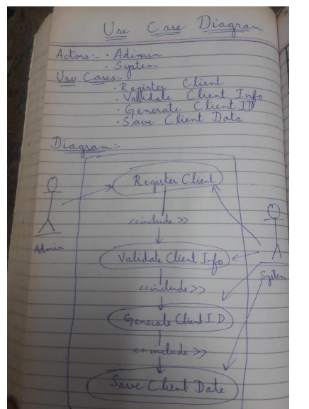**

**SUDAIS MURAD (USE CASE DIAGRAM):**  
Use Case: Process Payment  
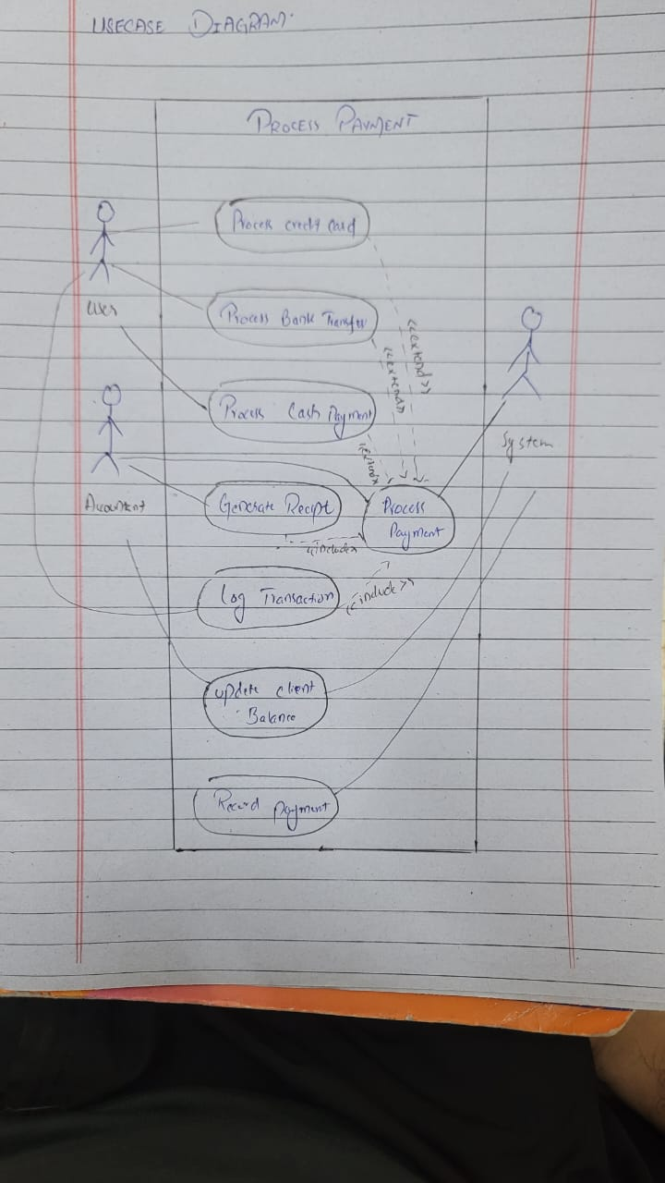

**SHAYAN MUGHAL (USE CASE DIAGRAM):**Use case: Submit Invoice  
  
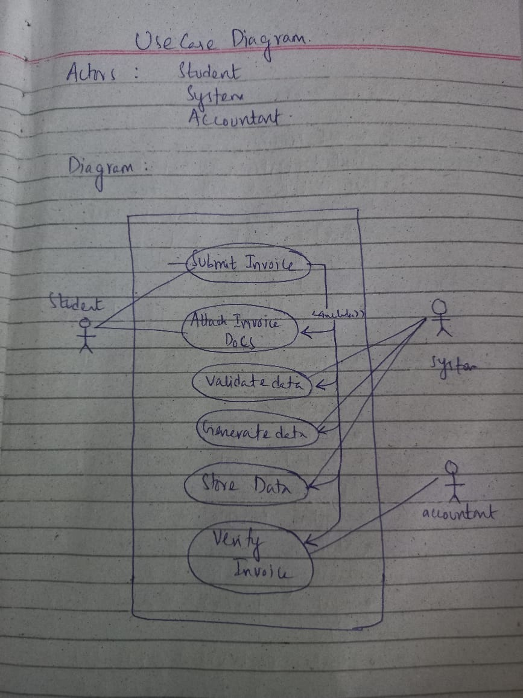

**MASHOOD AZAM (USE CASE DIAGRAM):**  
Use Case: Send Payment Reminder  
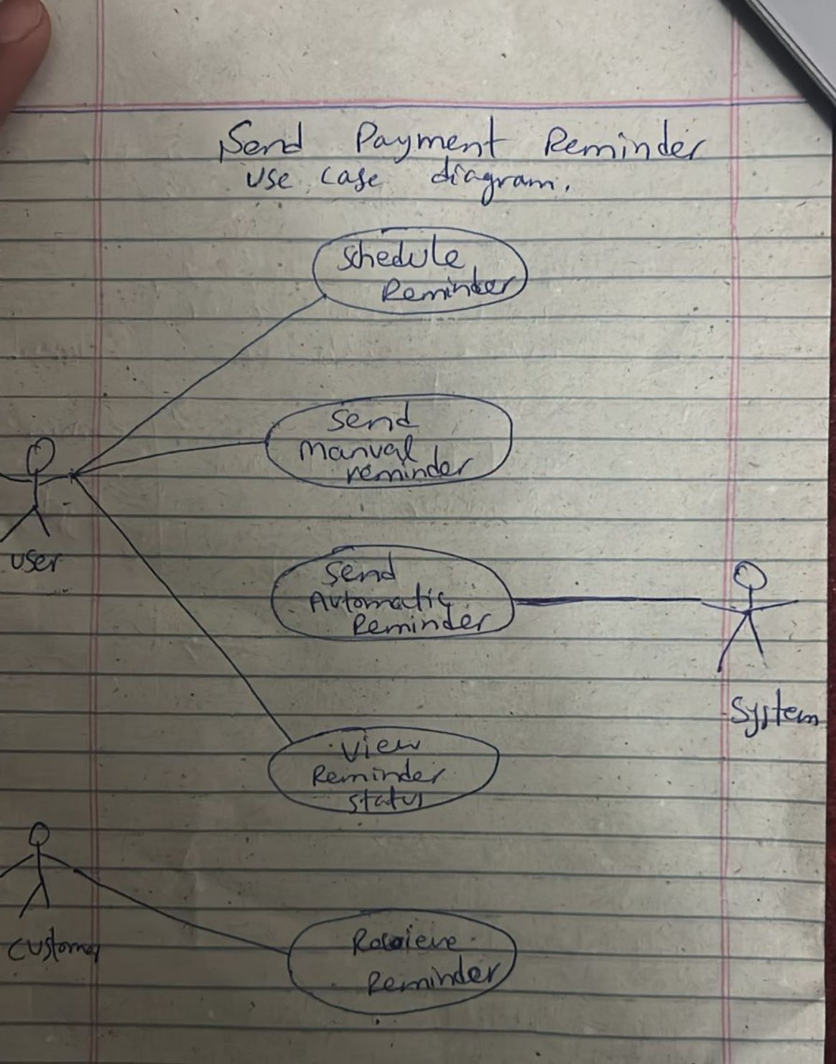

**HAFIZ KHIZAR (USE CASE DIAGRAM):**  
Use Case: Generate Fee Receipt  
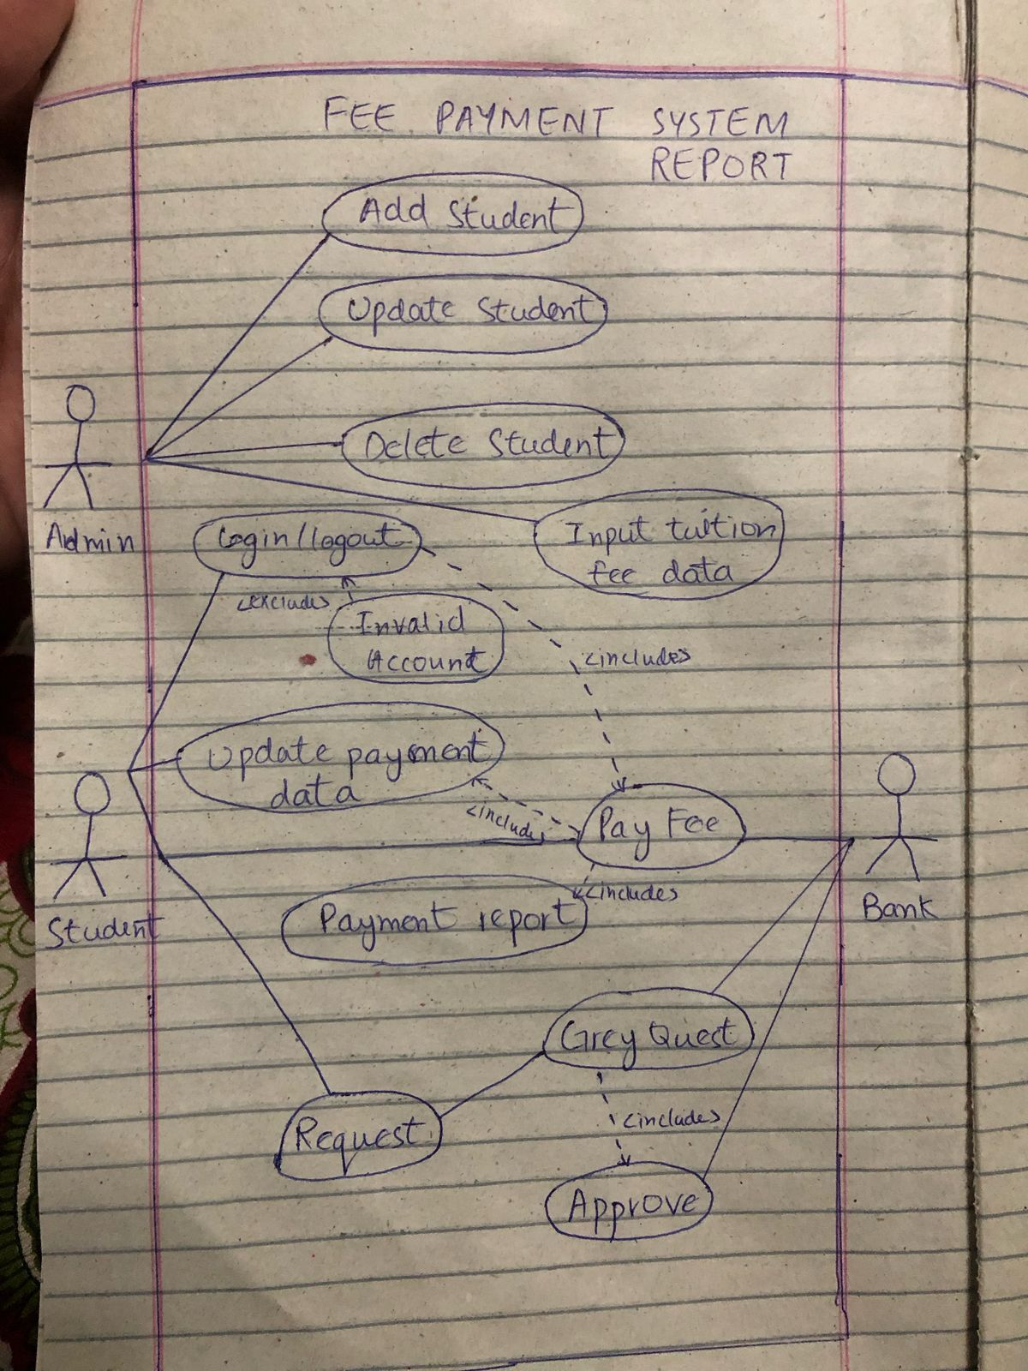

**KAMRAN FIAZ (USE CASE DIAGRAM):**  
**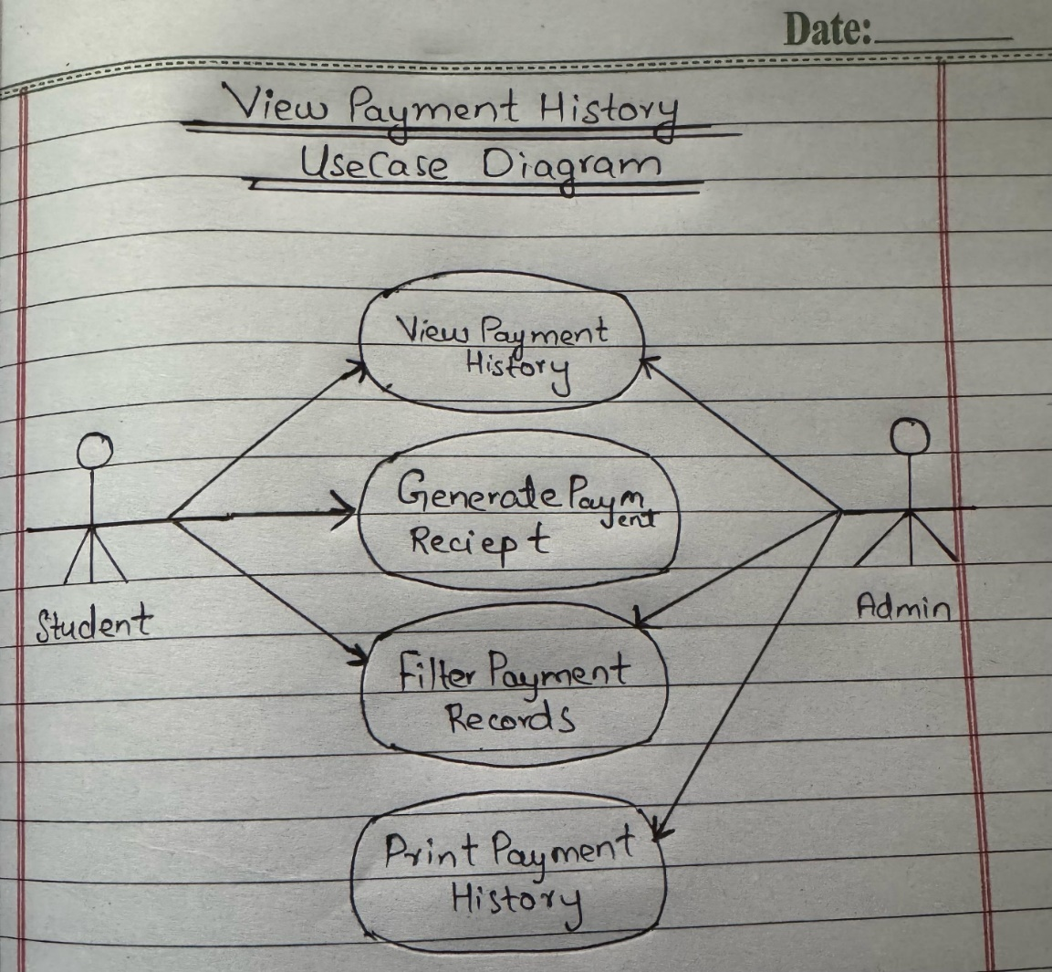**

**CHAPTER 2: FULLY DRESSED USE CASE  
  
Ahmed Irshad:  
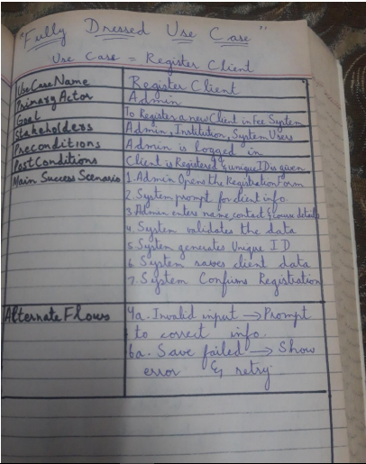**

**SUDAIS MURAD:**  
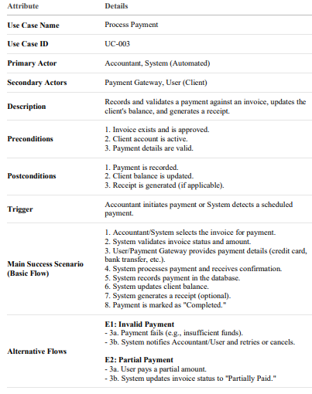

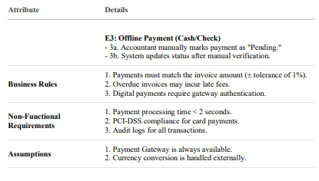

**SHAYAN MUGHAL:**  
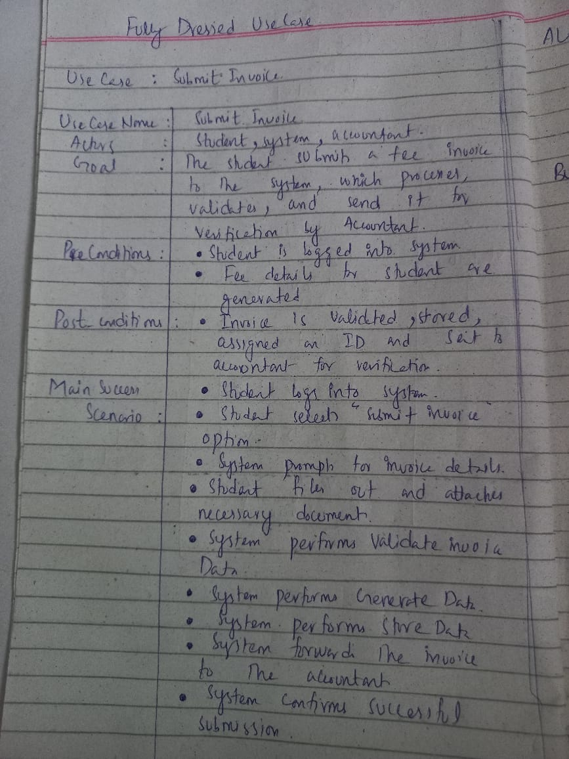

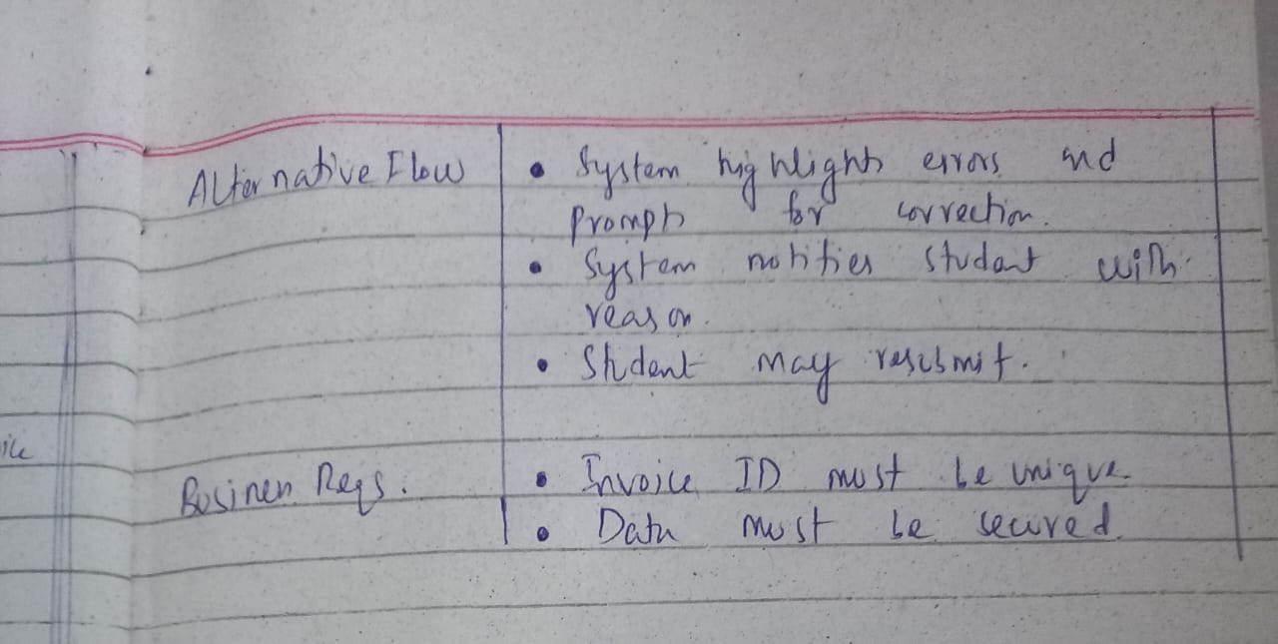

## **MASHOOD AZAM:**

|  |  |
| --- | --- |
| Attribute | Details |
| Use Case Name | Send Payment Reminder |
| Scope | Payment Reminder System |
| Level | User Goal |
| Primary Actor | User (Admin or Staff) |
| Secondary Actor(s) | System, Customer |
| Stakeholders and Interests | - \*\*User/Admin:\*\* Wants to ensure customers are reminded of due payments. - \*\*Customer:\*\* Wants timely reminders to avoid penalties. - \*\*System:\*\* Automates reminders to reduce manual effort. |
| Preconditions | - The customer has a pending payment. - The due date is defined in the system. - Contact information (email/SMS) is available. |
| Postconditions | - The customer has received the reminder (email/SMS/notification). - Reminder status is updated in the system. |
| Main Success Scenario | 1. User logs into the system. 2. User selects a customer or invoice with a due payment. 3. User selects 'Send Payment Reminder.' 4. The system fetches customer contact details. 5. The system sends a reminder via the configured channel (email/SMS). 6. The system logs the reminder in the reminder history. 7. Customer receives the reminder. |
| Extensions (Alternative Flows) | 3a. Reminder is scheduled instead of sent immediately. 5a. Email/SMS server is unavailable → System retries or logs failure. 7a. Customer's contact info is invalid → System flags the error. |
| Special Requirements | - Reminder templates should be editable. - Multiple channels supported (Email, SMS, App). - System must support scheduling and recurring reminders. |
| Frequency of Use | Daily or as configured. |

## **HAFIZ KHIZAR:**

|  |  |
| --- | --- |
| Use Case Name | Generate Fee Payment Report |
| Actor(s) | Admin, Accountant |
| Description | This use case allows the admin or accountant to generate a detailed report of student fee payments for record-keeping and analysis. |
| Trigger | The user selects the option to generate a fee report from the system interface. |
| Preconditions | The user must be logged into the system with appropriate privileges. |
| Postconditions | The system generates and displays/downloads the fee payment report. |
| Normal Flow | 1. User navigates to the reports section. 2. User selects 'Generate Fee Payment Report'. 3. User sets the desired filters (date range, student name, class, etc.). 4. System fetches relevant payment data. 5. System displays or allows download of the report. |
| Alternate Scenarios | 3a. No data available for selected filters:  - System shows 'No data found' message. |
| Special Requirements | The report must be exportable in PDF and Excel formats. |
| Frequency of Use | As required by the admin or accountant, typically monthly or on demand. |

**CHAPTER 3: SSDs  
  
Ahmed Irshad:**  
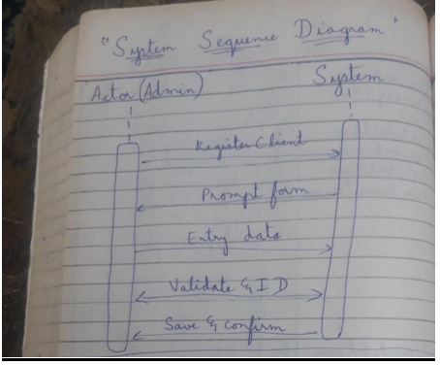

## **SUDAIS MURAD:**

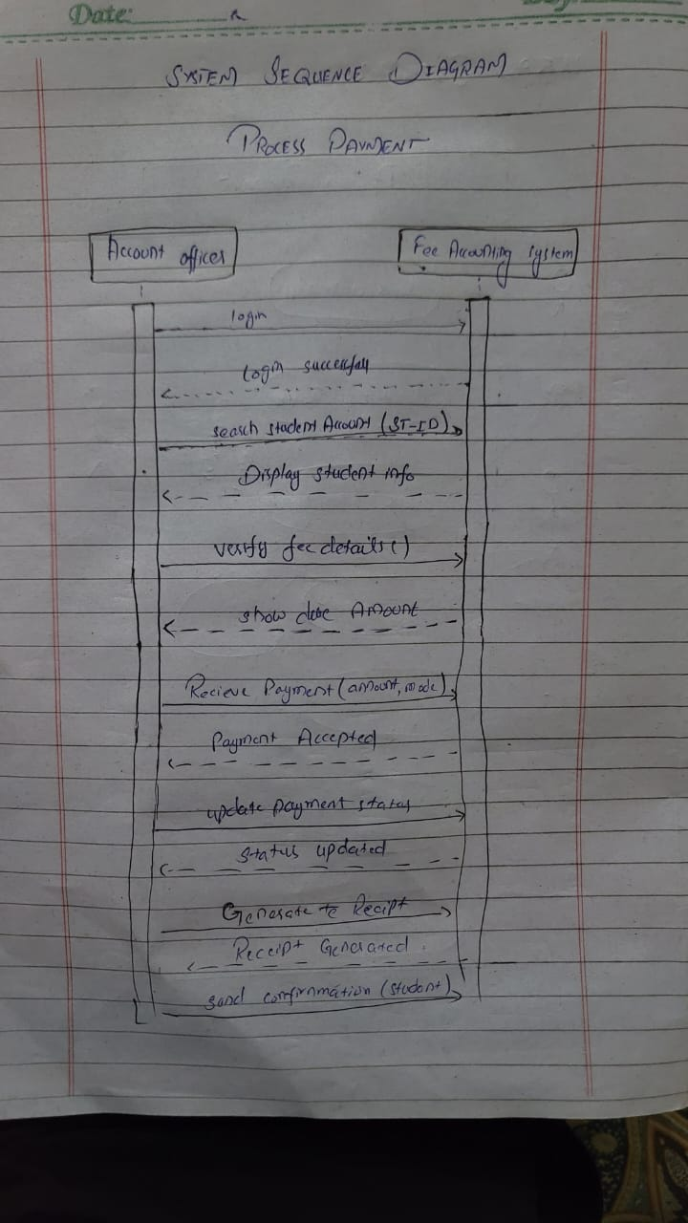

Shayan Mughal:  
  
  
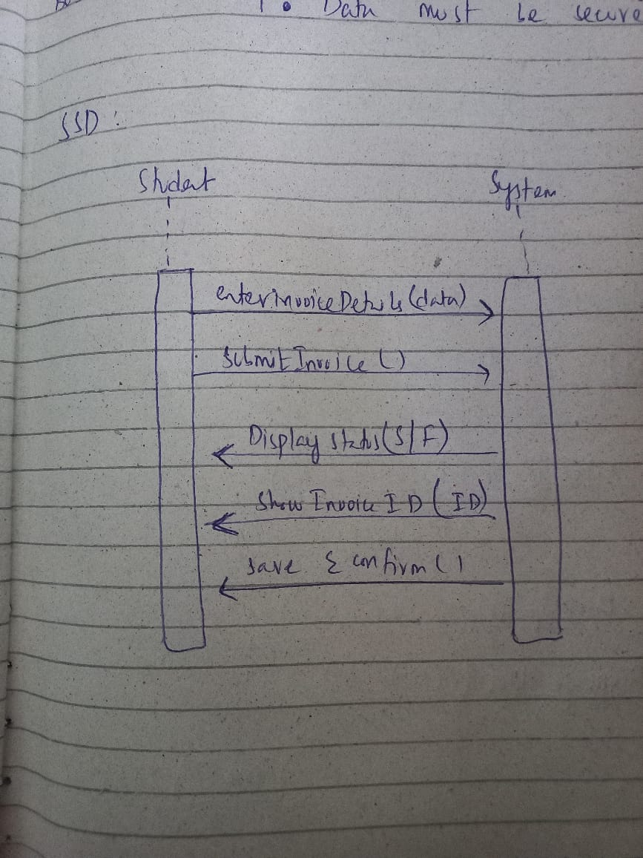

## **Mashood Azam:**

**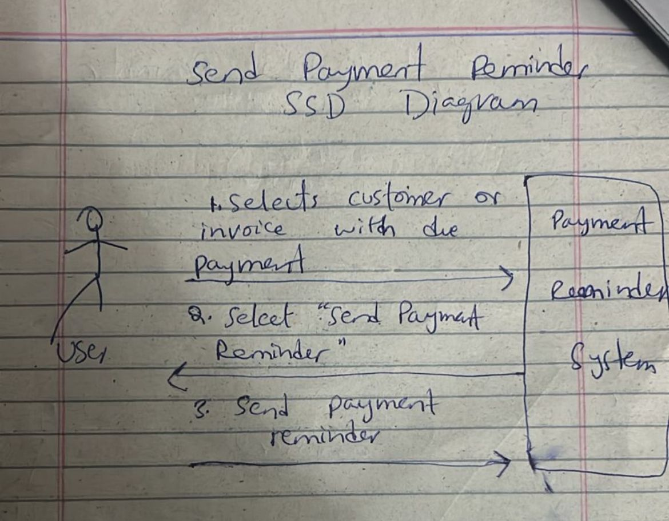**

**HAFIZ KHIZAR:**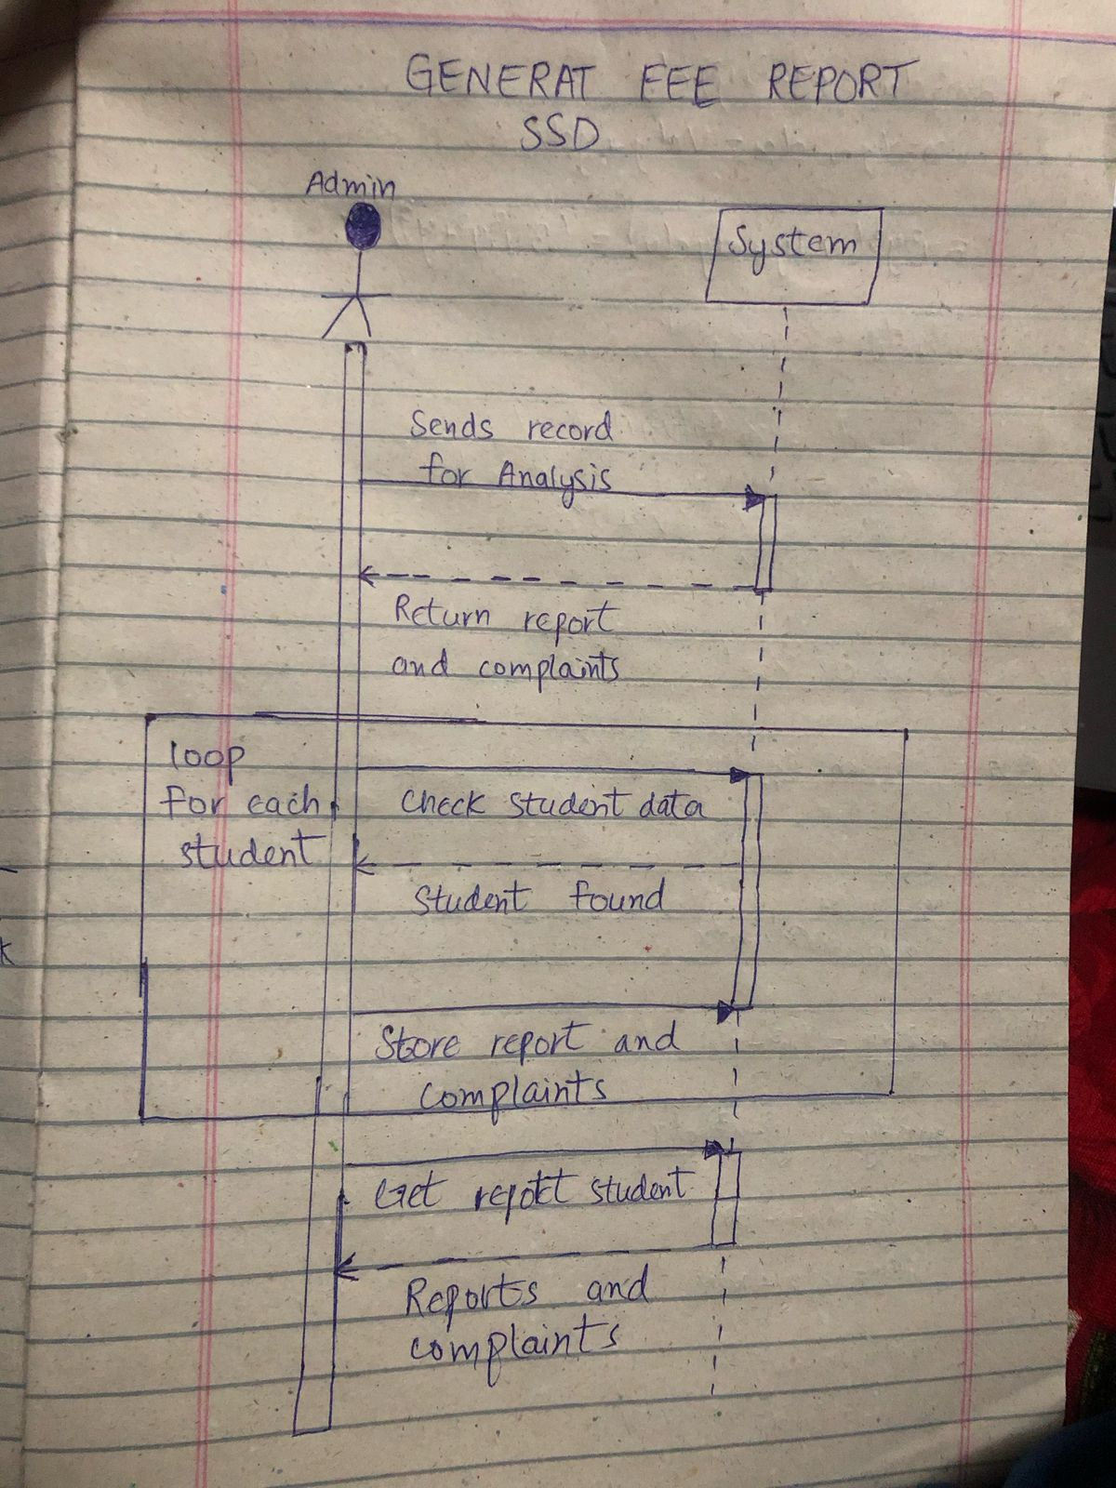

**KAMRAN FIAZ:**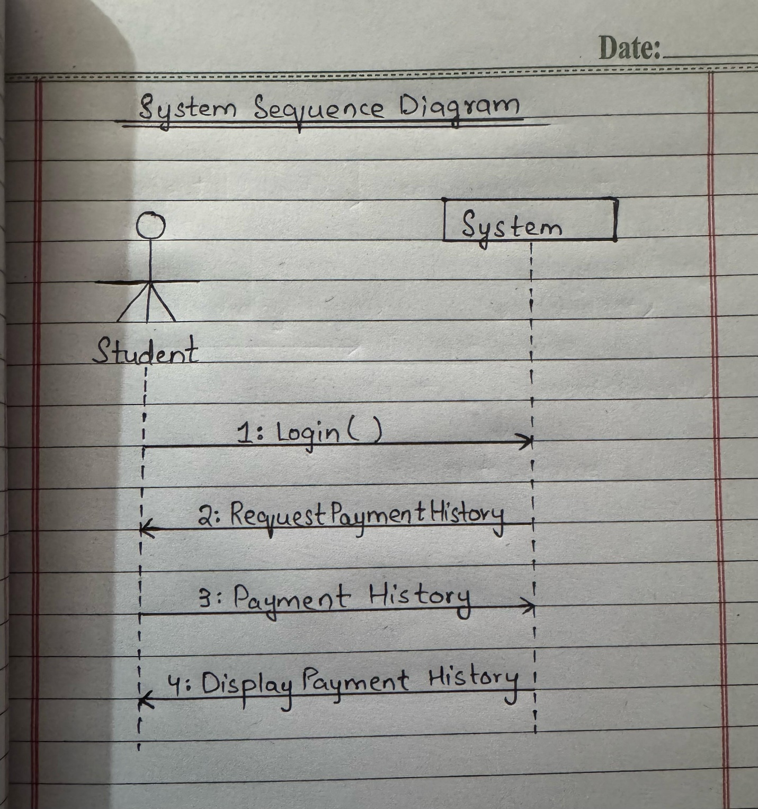

**CHAPTER 4: PACKAGE DIAGRAM  
  
AHMED IRSHAD:  
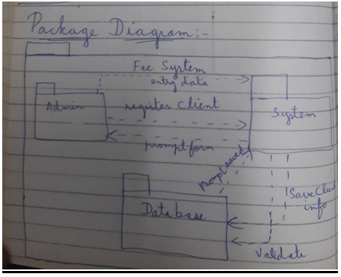**

SHAYAN MUGHAL:  
  
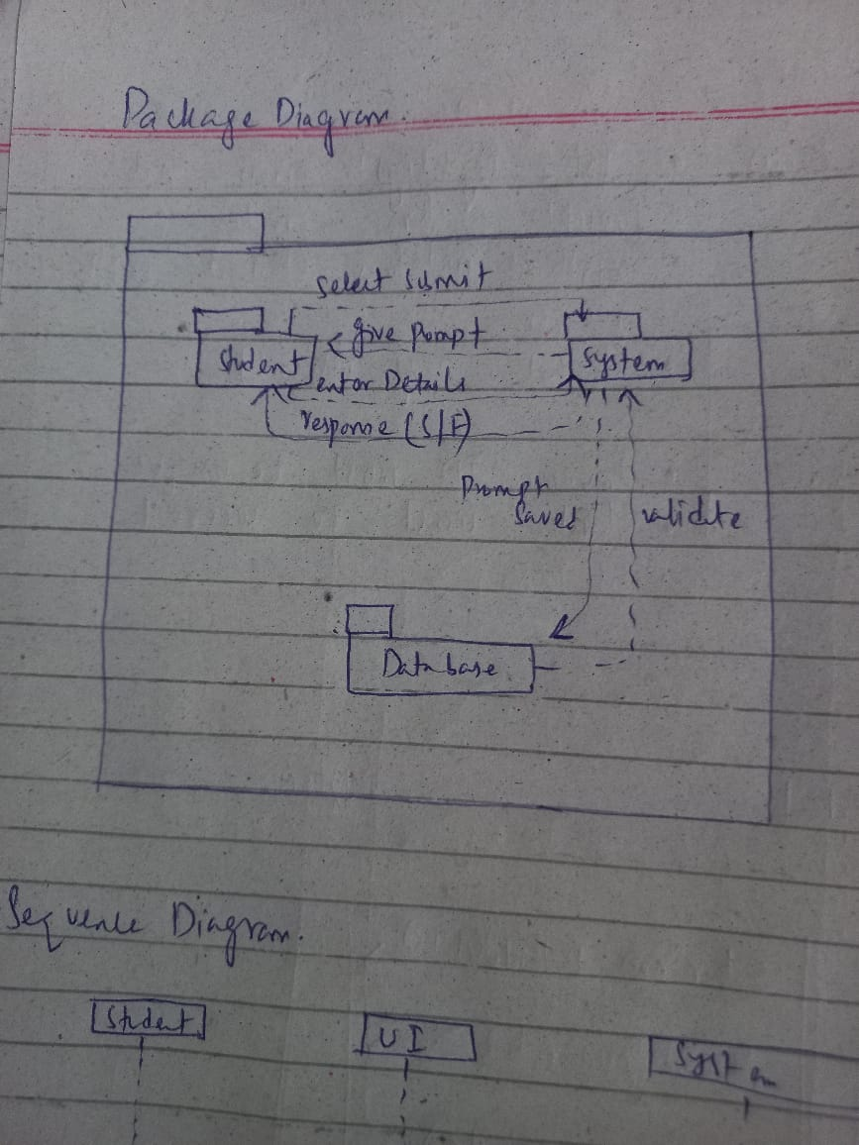

## **C:\Users\lenovo\AppData\Local\Packages\5319275A.WhatsAppDesktop_cv1g1gvanyjgm\TempState\D202ED5BCFA858C15A9F383C3E386AB2\WhatsApp Image 2025-05-03 at 02.51.47_c196a0d3.jpgSUDAIS MURAD:**

**MASHOOD AZAM:**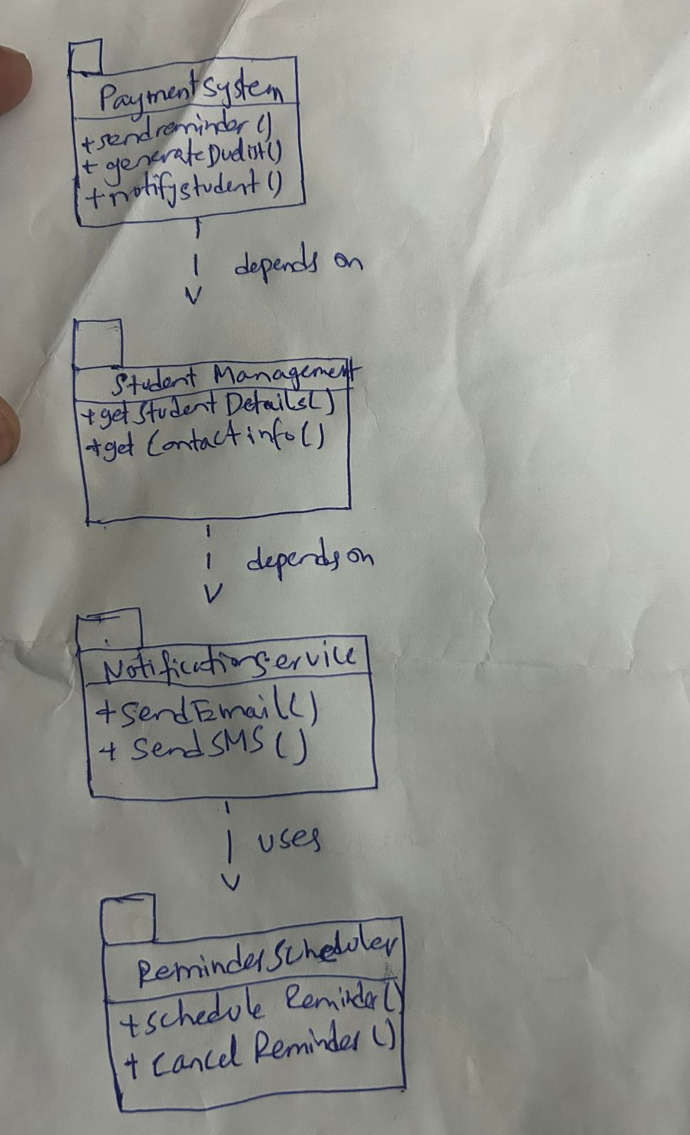

**HAFIZ KHIZAR:**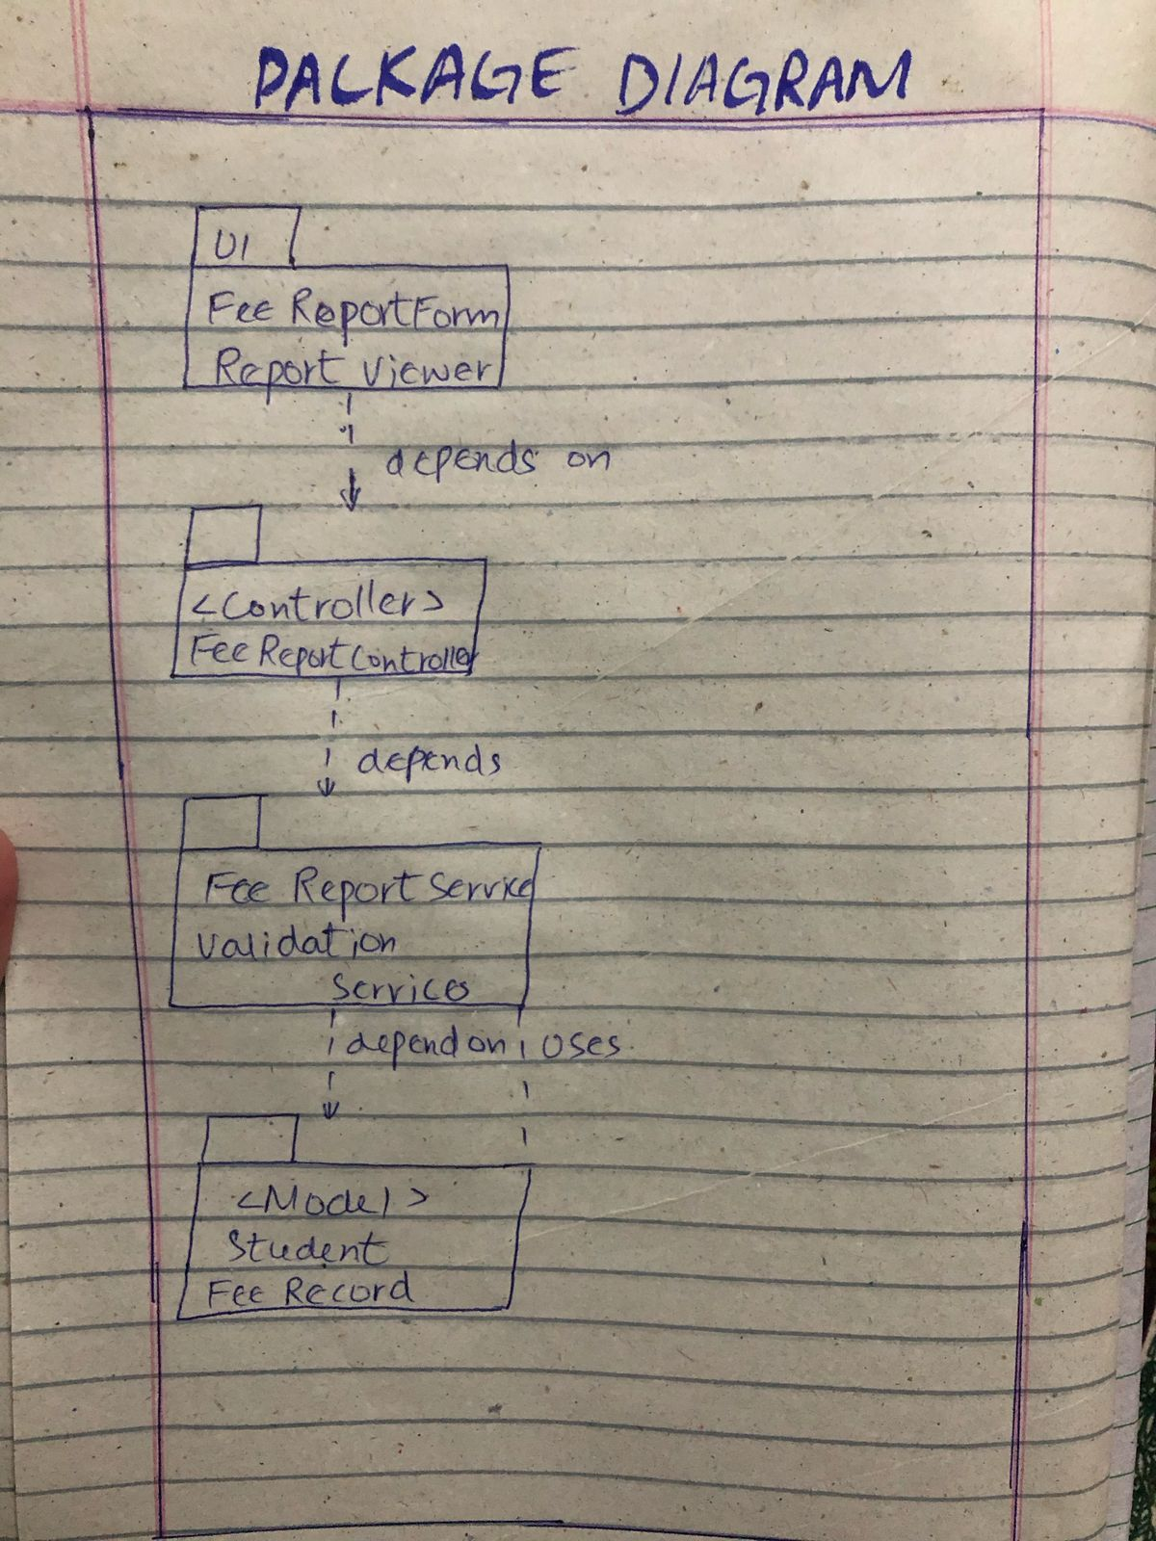

**KAMRAN FIAZ:  
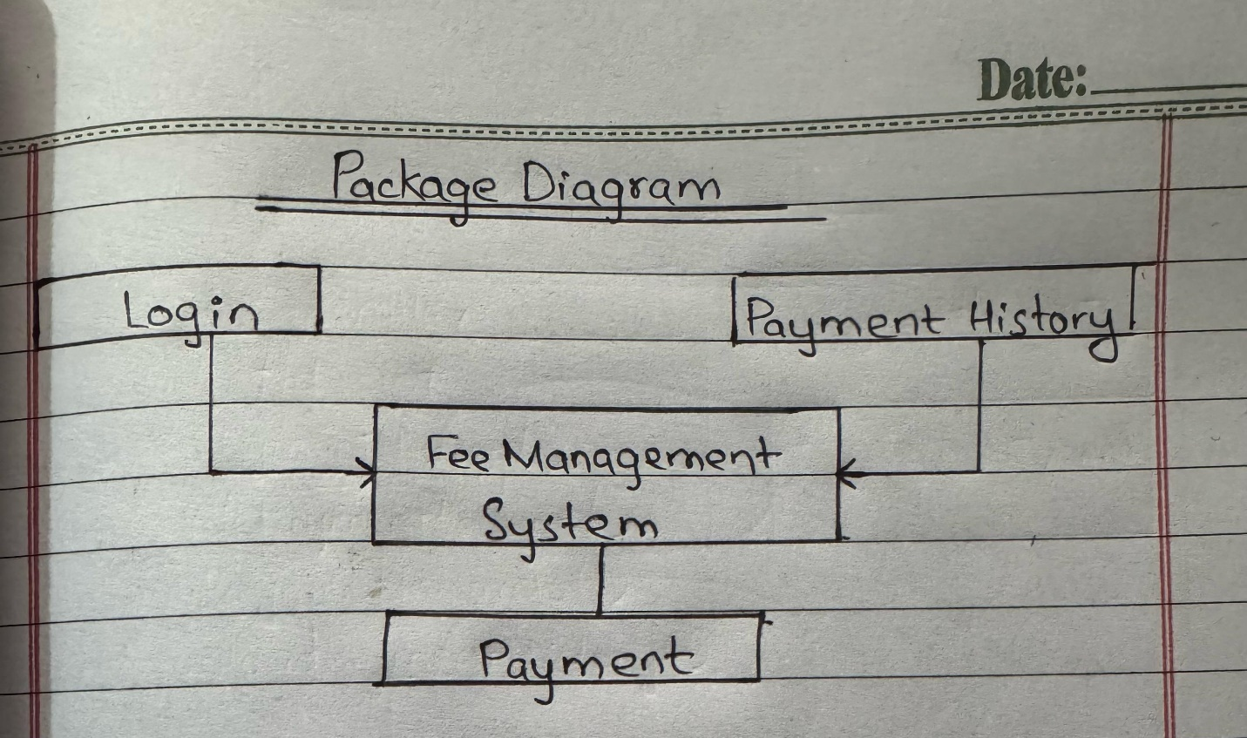**

# **CHAPTER 5: COMMUNICATION DIAGRAM**

**AHMED IRSHAD:  
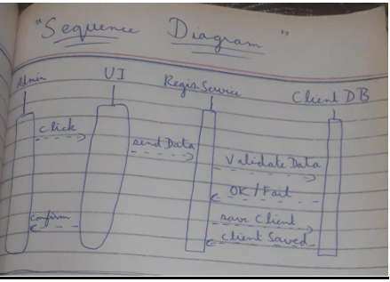**

**SHAYAN MUGHAL:  
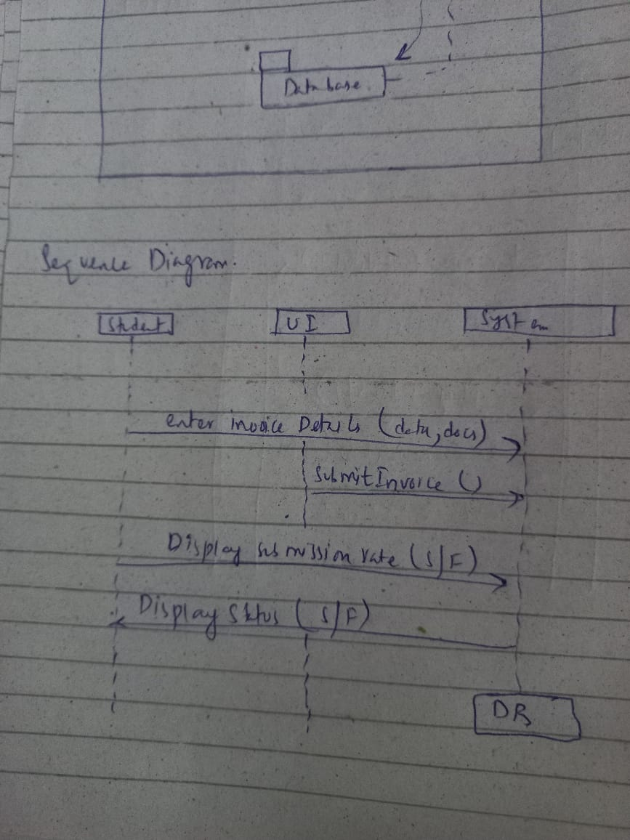**

## **SUDAID MURAD: C:\Users\lenovo\AppData\Local\Packages\5319275A.WhatsAppDesktop_cv1g1gvanyjgm\TempState\ACEACD5DF18526F1D96EE1B9714E95EB\WhatsApp Image 2025-05-03 at 02.51.46_58f1ff76.jpg**

**KAMRAN FIAZ:  
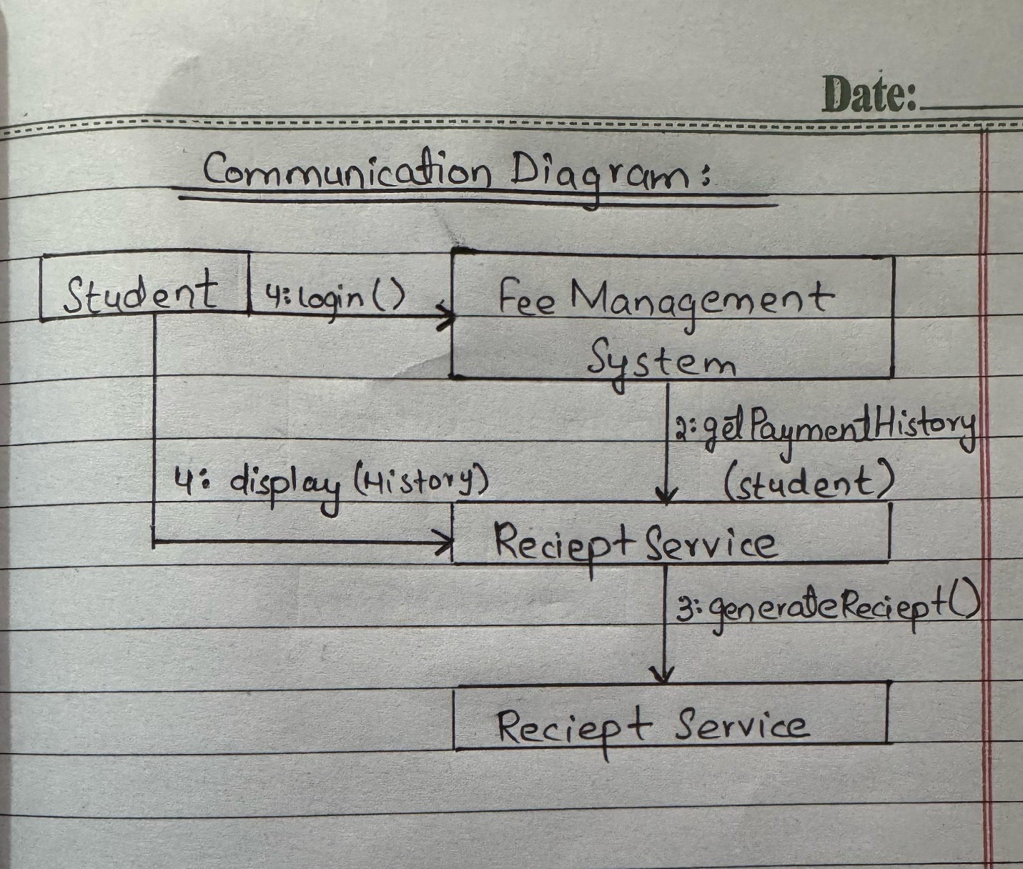**

**MASHOOD AZAM:  
User/Admin PaymentSystem StudentManagement NotificationService**

**| | |** **|**

**|--- initiateReminder() ----------------->| |**

**| | | |**

**| |--- getDueStudents() ------------------------->|**

**| | |<----- dueList --------|**

**| |--- getContactInfo(student) ----------------->|**

**| | |<--- contactDetails ---|**

**| |--- sendReminder(contactDetails) ------------>|**

**| | | |--- sendEmail() / sendSMS()**

**| | | |<-- Confirmation**

**|<-- Confirmation --| | |**

## **HAFIZ KHIZAR:**

User ui:FeeReportUI controller:FeeReportController service:FeeReportService repo:FeeReportRepository db:Database

| | | | | |

|**1:** clickGenerateReport() | | | |

|-------------------------------------------->| | | |

| |**2:** generateReport(filters) | | |

| |--------------------------------------------->| | |

| | |**3:** getReportData(filters)| | |

| | |------------------------->| | |

| | | |**4:** fetchData(filters) | |

| | | |--------------------------->| |

| | | | |**5:** queryDB(sql) |

| | | | |---------------------->|

| | | |**6:** dataRows | |

| | | |<---------------------------| |

| | |**7:** reportData | | |

| | |<------------------------| | |

| **|8:** display(reportData) | | | |

|<-------------------| | | | |

| | | | | |

**CHAPTER 6: CLASS DIAGRAMS:  
AHMED IRSHAD:  
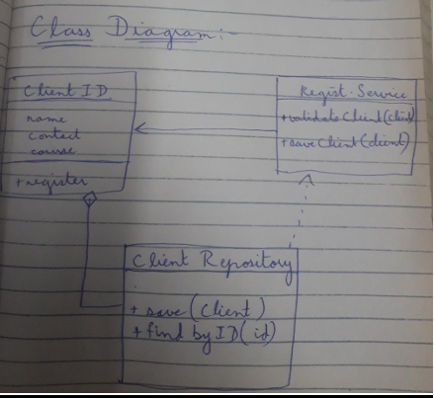**

**SHAYAN MUGHAL:  
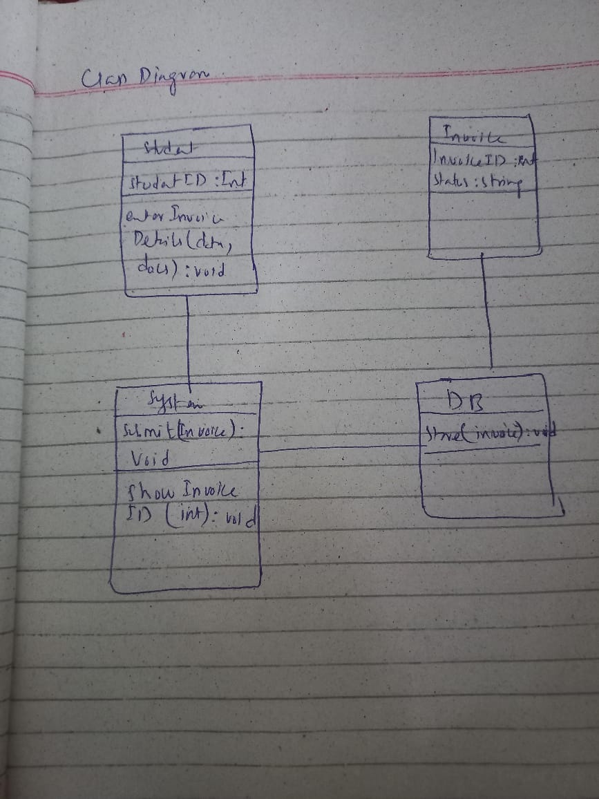**

## **C:\Users\lenovo\AppData\Local\Packages\5319275A.WhatsAppDesktop_cv1g1gvanyjgm\TempState\D77C703536718B95308130FF2E5CF9EE\WhatsApp Image 2025-05-03 at 02.51.47_45c0d07b.jpgSUDAIS MURAD:**

**MASHOOD AZAM:  
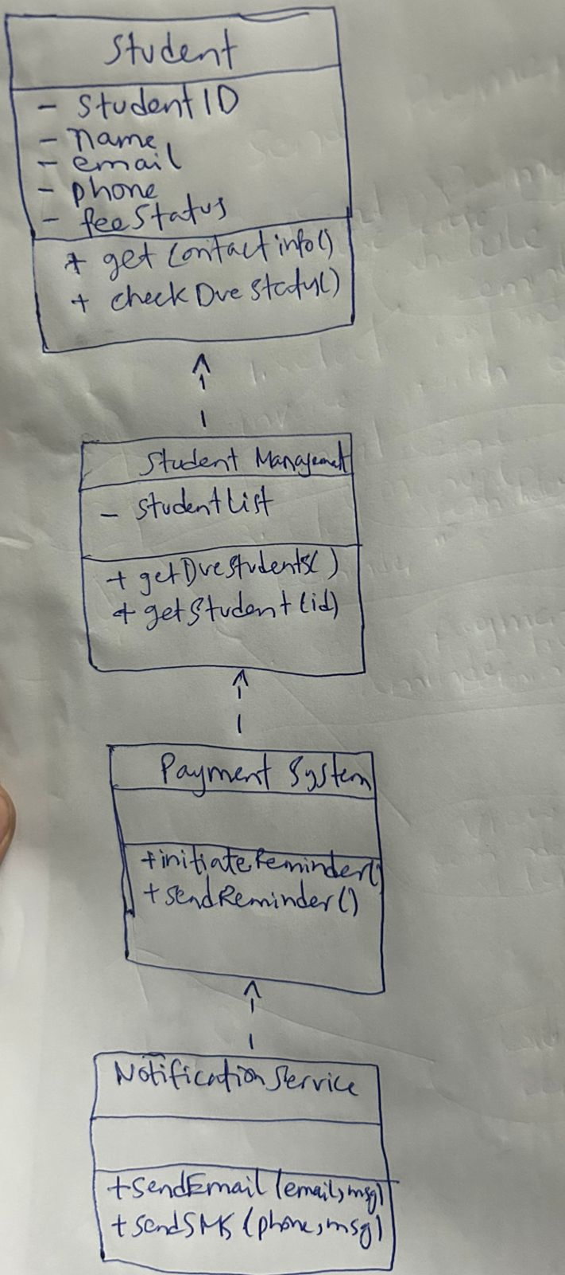**

**HAFIZ KHIZAR:**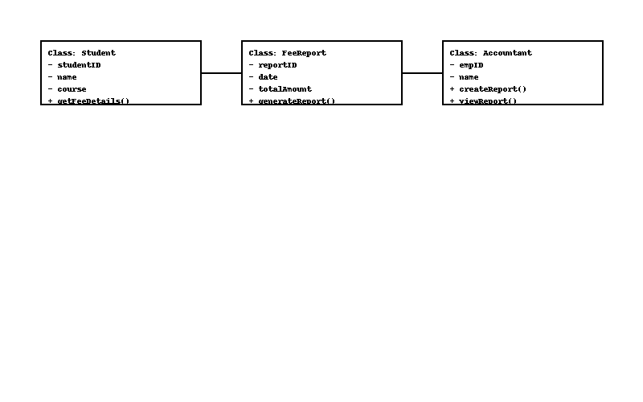

**KAMRAN FIAZ:  
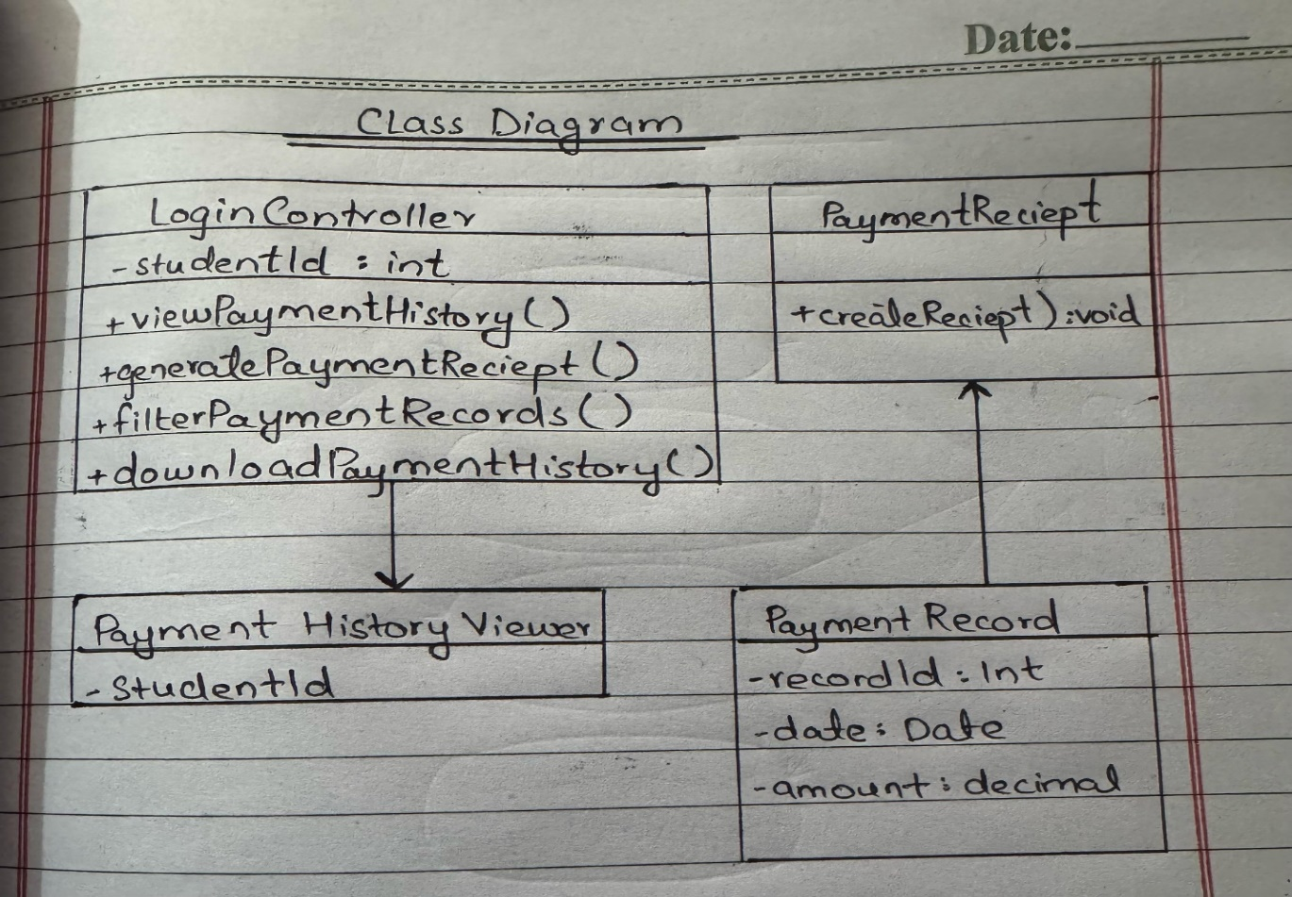**

# **CHAPTER 7: CODING STANDARDS**

## **AHMED IRSHAD:**

**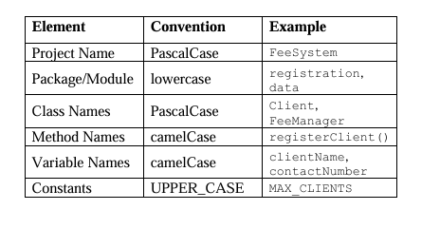**

**2. Folder/Package Structure:**

feesystem/

├── models/ # Data classes (e.g., Client)

├── services/ # Business logic (e.g., RegistrationService)

├── repository/ # Data handling (e.g., ClientRepository)

├── ui/ # Console or GUI interfaces

└── utils/ # Helper methods, validation, etc.

**3. Code Formatting:**

* Indentation: 4 spaces (no tabs)
* Line Length: Max 100 characters
* Braces: Open on the same line (Java style)

if (isValid) {

registerClient(client);}

**1. Error Handling:**

try {

clientRepository.save(client);

} catch (DatabaseException e) {

System.err.println("Error saving client: " + e.getMessage());}

**5. Validation and Security:**

* Validate all user inputs (null checks, format checks, etc.).
* Sanitize inputs to avoid injection or corruption.
* Use encapsulation: keep class fields private, expose through getters/setters.

**6. Testing Standards (optional for now):**

* Write test cases for methods like validateClient(), saveClient().
* Use dummy/mock objects for testing repository behavior.

## **SUDAIS MURAD:**

**Folder/Package Structure**

bash CopyEdit feesystem/

├── models/ # Data classes (e.g., Payment)

├── services/ # Business logic (e.g., PaymentProcessor)

├── repository/ # Data storage logic (e.g., PaymentRepository)

├── ui/ # Interfaces for payment input/output

└── utils/ # Validation, currency formatting, etc.

# Code Formatting

* + **Indentation**: 4 spaces (no tabs)
  + **Line Length**: Max 100 characters
  + **Braces**: Open on same line

Java

if (paymentAmount > 0) { processPayment(studentId, paymentAmount);

}

# Error Handling

Use try-catch for any payment failures (e.g., database, API):

java CopyEdit try {

paymentRepository.save(payment);

} catch (PaymentException e) {

System.err.println("Payment failed: " + e.getMessage());

}

# Validation and Security

* + Validate fields like studentId, amount, paymentMode
  + Check for null, negative values, or invalid formats
  + Sanitize all inputs before processing
  + Use encapsulation:

java CopyEdit

private double paymentAmount;

public double getPaymentAmount() { return paymentAmount;

}

# Testing Standards (optional for now)

* + Write test cases for:
    - processPayment()
    - validatePaymentDetails()
    - calculateLateFee()
  + Use mock repositories or services to isolate logic during testing

#### MASHOOD AZAM: 1. **Package Naming**

* Use all **lowercase** letters.
* Names should be short, meaningful, and based on functionality (e.g., usermanagement, reporting).

#### 2. **Class Naming**

* Use **PascalCase** (each word starts with a capital letter).
* Class names should be **nouns** that reflect their responsibility (e.g., ReminderScheduler, EmailSender).

#### 3. **Method Naming**

* Use **camelCase** (first word lowercase, following words capitalized).
* Method names should be **verbs** that describe the action (e.g., sendReminder, generateReport).

#### 4. **Variable Naming**

* Use **camelCase**.
* Names should be meaningful and self-descriptive (e.g., dueDate, customerEmail).
* Avoid single-letter or vague variable names.

#### 5. **Access Modifiers**

* Use appropriate access modifiers:
  + private for internal fields
  + public for externally accessible methods
  + Avoid public fields

#### 6. **Constants**

* Use final and all **UPPER\_SNAKE\_CASE** for constants.
* Define constants in a separate utility class if needed.

#### 7. **Code Structure**

* Follow this order in each class:
  1. Fields
  2. Constructors
  3. Public methods
  4. Private/helper methods

#### 8. **Documentation**

* Use **JavaDoc** comments for:
  + Each public class and method
  + Parameters and return values

#### 9. **Exception Handling**

* Use proper try-catch blocks where exceptions might occur (e.g., sending emails, file export).
* Don’t ignore exceptions silently.

#### 10. **Separation of Concerns**

* Keep each class focused on a **single responsibility**.
* Avoid mixing UI, business logic, and data handling in the same class.

#### 11. **Code Readability**

* Use proper **indentation and spacing**.
* Leave a blank line between methods.
* Avoid writing long methods; split into smaller helper methods if needed.

#### 12. **Modular Design**

* Divide functionality logically across **packages** and **classes**.
* Ensure minimal coupling and high cohesion.

## **HAFIZ KHIZAR:**

| **Aspect** | **Standard / Guideline** |
| --- | --- |
| **Naming Conventions** | - Class names: PascalCase (e.g., FeeReportService)  - Methods/variables: camelCase |
| **Comments** | - Use meaningful comments above classes and methods  - Avoid redundant comments |
| **Indentation** | - 4 spaces per indentation level |
| **Code Modularity** | - Break down logic into small, reusable methods |
| **Constants** | - Use final static constants for fixed values |
| **Error Handling** | - Use try-catch blocks where necessary  - Throw custom exceptions if needed |
| **Layered Architecture** | - Use layers: UI ➝ Controller ➝ Service ➝ Repo |

**KAMRAN FIAZ:  
1. General Coding Standards:**

• Follow naming conventions:

• Variables/methods: camelCase (e.g., getPaymentHistory())

• Classes: PascalCase (e.g., PaymentHistoryController)

• Constants: UPPER\_SNAKE\_CASE

• Use meaningful names: Avoid temp, data, or xyz; instead use paymentList, studentId, etc.

• Keep functions short and single-responsibility

• Avoid hardcoding values; use config files or constants.

**2. Backend (e.g., Java, Python, Node.js):**

• Use layered architecture (Controller → Service → Repository)

• Example file structure (Java Spring Boot):

/controller/PaymentHistoryController.java

/service/PaymentHistoryService.java

/repository/PaymentRepository.java

/model/Payment.java

Handle exceptions with meaningful messages (e.g., PaymentHistoryNotFoundException)

• Use DTOs (Data Transfer Objects) to limit exposure of sensitive fields.

• REST API endpoint naming: /api/payments/history/{studentId}

**3. Frontend (e.g., React, Angular, Vue):**

• Component naming: PaymentHistoryComponent, PaymentRow

• Avoid inline styles, use CSS/SCSS files or CSS modules.

• Use state management (e.g., Redux, Vuex) where appropriate.

• Implement loading and error states

• Sanitize user input (especially filters and form data).

**4. Database Design:**

• Use normalized schema

• Table: payments

• payment\_id (PK)

• student\_id (FK)

• amount

• date

• payment\_method

• status

• Use consistent naming, avoid abbreviations

• Use indexes on student\_id, date for performance

**5. Security Best Practices:**

• Use parameterized queries to prevent SQL injection

• Mask sensitive info like card details in frontend/backend logs

• Authenticate and authorize access to payment history via tokens (e.g., JWT)

**6. Documentation & Comments:**

• Use doc comments (/\*\* \*/ in Java, /// in Dart) to explain function purpose

• Keep inline comments concise and relevant

• Write README or API documentation using Swagger/OpenAPI

**SHAYAN MUGHAL:  
